PSED SMSC |  |  |  |  |  |  | Physical development |  |  |  |  |  | Communication and language
Relationships  RE |  |  | Confidence/ awareness |  |  | Feelings/ behaviour | Moving and handling |  |  | Health and self-care |  |  | Listening/ attention |  | Understanding | Speaking
Why do we visit the church?  Visit to the church.  Interview Rev Claire  Ask own questions.  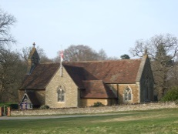 |  | Keeping safe, NSPCC,  Sun safety, water safety  School trips.  Safe journeys |  |  |  | Emotions  I am happy when?  I make others happy when  I make others unhappy when? | Scissors - cutting skills, pencils threading  Forming recognisable letters.  Cosmic Yoga.  Why is it important to keep fit?  Sports day linked to PSED being a good sport and trying your best.  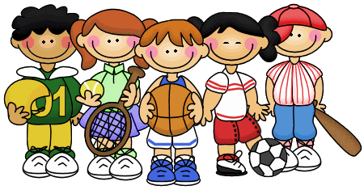 |  |  |  |  |  | Show and tell, speaking and listening, asking and answering questions.  Following instructions.  Asking and answering questions linked to RE  Interviewing visitors e.g. Rev Claire  Rules for trips.
Rumble in the Jungle
Value~ Friendship, |  |  |  |  | British values: We listen carefully to other people’s views  We make our own choices and understand the rewards or consequences of our actions.
Literacy |  |  |  | Mathematics |  |  |  |  | Understanding the world |  |  |  |  | Expressive arts and design
Reading | Writing |  |  | Numbers |  |  |  | Shape space measures | People and communities |  | The world | Technology |  | Media/materials |  |  | Imaginative
Stories we will read are  Rumble in the jungle, Giraffes can’t dance, The selfish crocodile, Handa’s surprise,  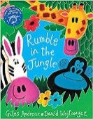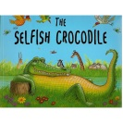  We will be writing  Questions, tickets, orders  Posters and safety signs |  |  |  | Halving fruit.  Subtracting fruit  Money in role-play car wash, pizza delivery  Counting and grouping into tens. Animals in the zoo.  Making pictures from shapes e.g. zoo pictures  Capacity for jungle juice.  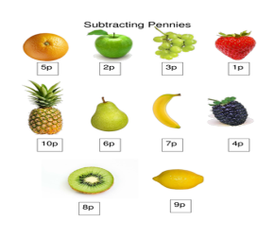 |  |  |  |  | Talk about family news and events  Compare similarities and differences.  Looking at maps and journeys  Use simple programs on the computer.  Drag and drop using a mouse.  Give instructions to a bee-bot.  Ask and answer relevant questions about journeys  Floating and sinking experiments.  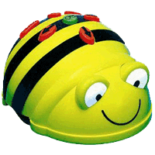 |  |  |  |  | Using different techniques  Printing,  Colour mixing  Sculptures with natural materials.  Singing songs, Down in the jungle  Listen to music –

